<$ScrKeepWithNext><$Scr_H::1><$Scr_Ps::0>Complexity II
<!$Scr_H::1><!$Scr_Ps::0>
  - Diagrams

Q: Which is simpler, diagram A or

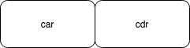
diagram B?

  - 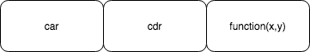
  - Code
Q: Which code is simpler? Code C:
function Cons(x,y) {
this.car = x;
this.cdr = y;
};
function car(cell) {
return cell.car;
};
function cdr(cell) {
return cell.cdr;
};

or Code D?
function Cons(x,y) {
return function(placeholderFunction) {
placeholderFunction(x,y);
};
};
function car(cell) {
return cell(
function(x,y){
return x;
}
);
};
function cdr(cell) {
return cell(
function(x,y){
return y;
}
);
};

Simplicity can be defined as “lack of nuance”.

It is the Software Architect’s responsibility to make the design readable and understandable.

